Task Assignment & Evidence of Tool Usage
Library Management System – Group 02 (Stage 3 & 4: Implementation & Testing)

1. Task Assignment
STT | Họ tên | MSSV | Nhiệm vụ (Stage 3 & 4) | File phụ trách | Hoàn thành
1 | Nguyễn Quang Trường | 064206013556 | Xây dựng cấu trúc chương trình chính, menu điều hướng và lớp truy xuất dữ liệu | main.py, db.py | 100%
2 | Lâm Minh Nguyên | 052206006507 | Xử lý đăng nhập/xác thực cho Member và Admin, viết unit test xác thực | auth.py, test_auth.py | 100%
3 | Lã Nguyễn Hoàng Phúc | 068206007767 | Xây dựng các chức năng dành cho Member (xem thông tin, tìm sách, xem sách đang mượn, lịch sử mượn) và unit test tương ứng | member_ops.py, test_member_ops.py | 100%
4 | Bùi Minh Quân | 079206018842 | Xây dựng chức năng quản trị (quản lý thành viên/sách/mượn-trả) và logic tính tiền phạt (Fine) | admin_ops.py, fines.py | 100%
5 | Mai Nguyễn Khánh Ngân | 089306015518 | Viết unit test cho chức năng quản trị, lập tài liệu kiểm thử, đóng gói Docker và tổng kết báo cáo | test_admin_ops.py, Testing Document.xlsx, Test_Report.md, Dockerfile | 100%

2. Evidence of Tool Usage
• Python / Pytest
30/30 automated tests pass — see docs/Test_Report.md for the full pytest log.

• Docker
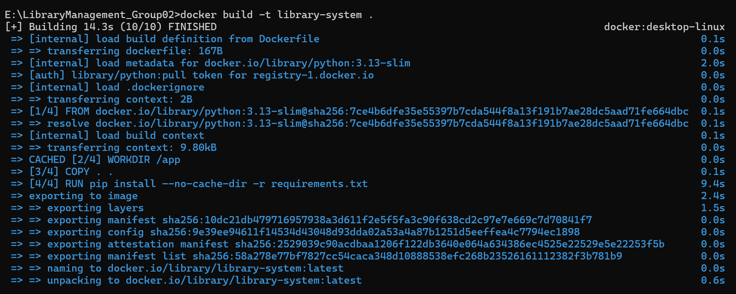
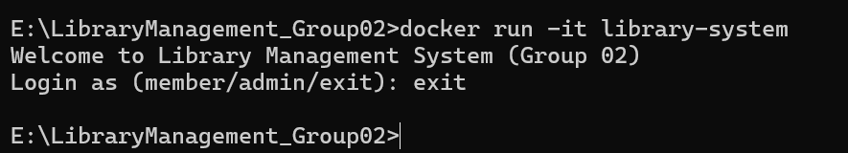

• IDE (VS Code / PyCharm / ...)
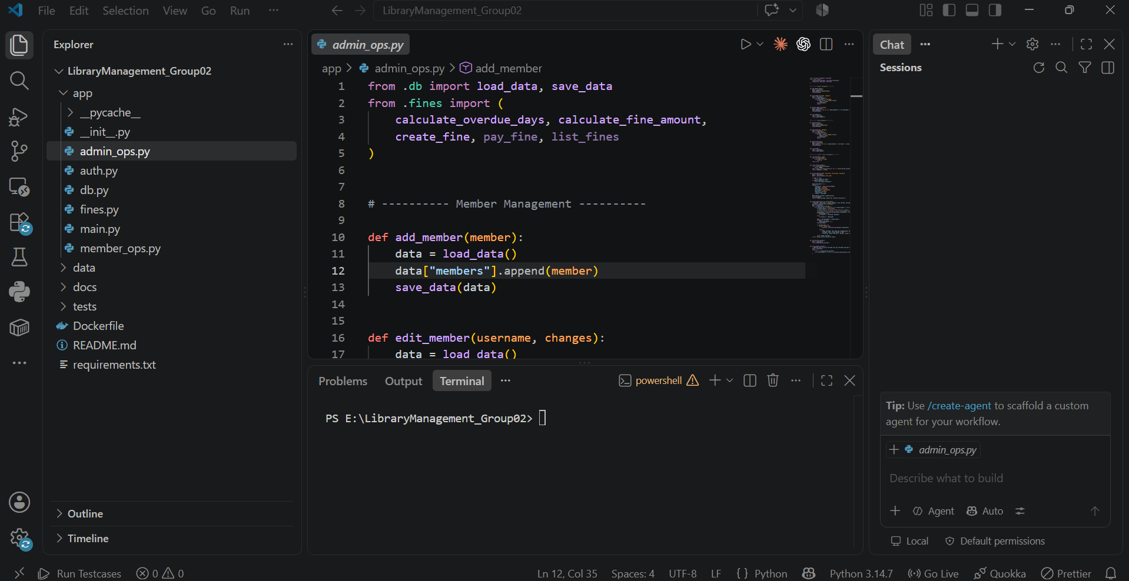

• GitHub / GitLab
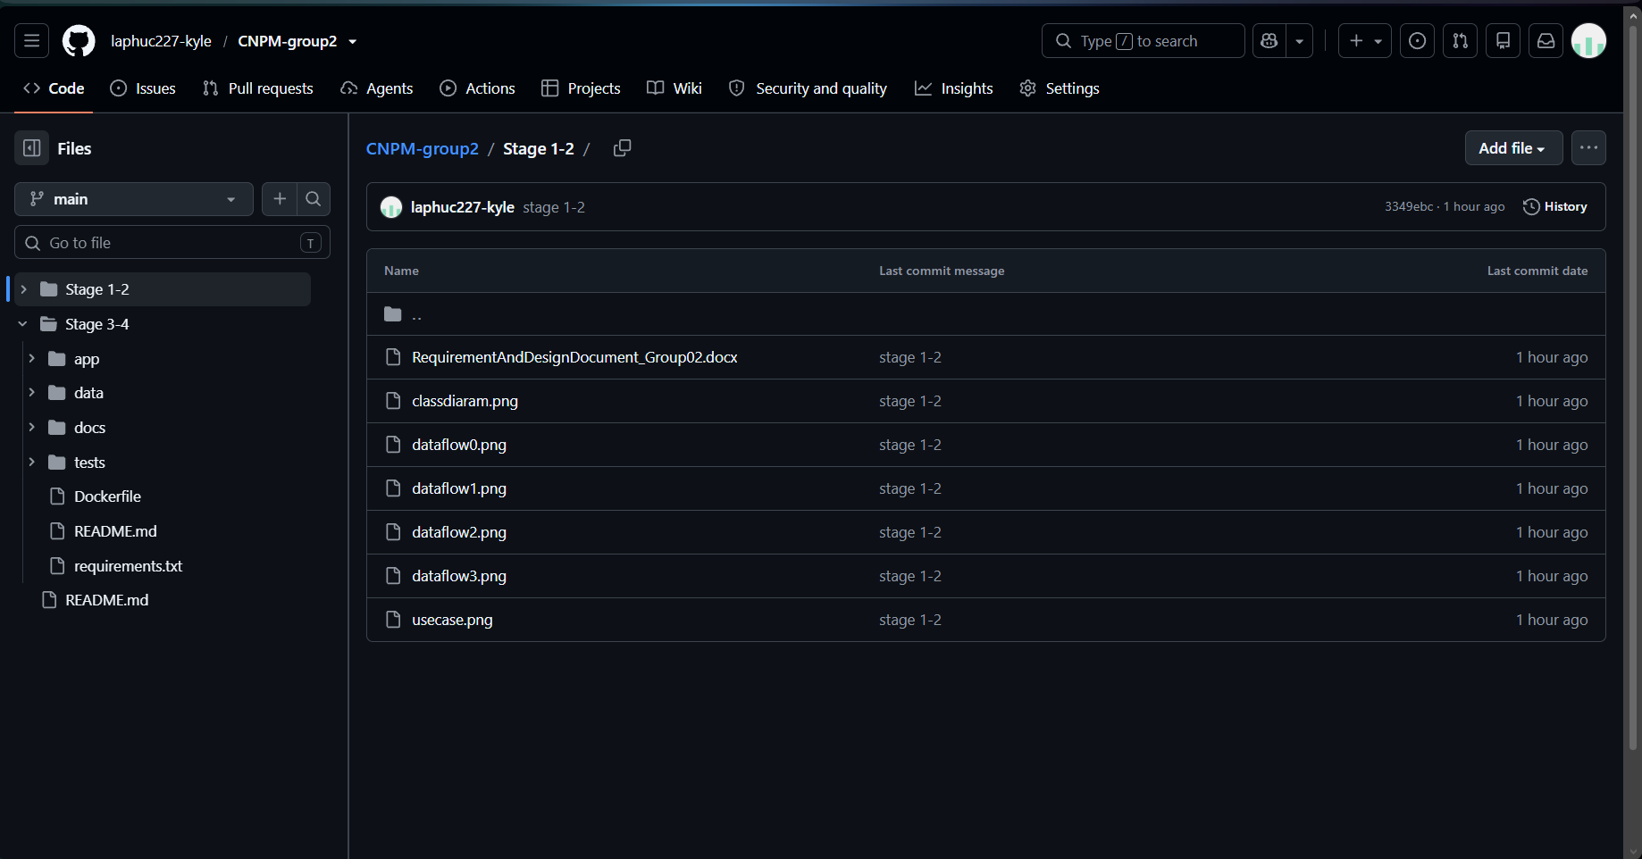
GitHub Repository: https://github.com/laphuc227-kyle/CNPM-group2.git

• draw.io (app.diagrams.net) — Data Model & sơ đồ khác
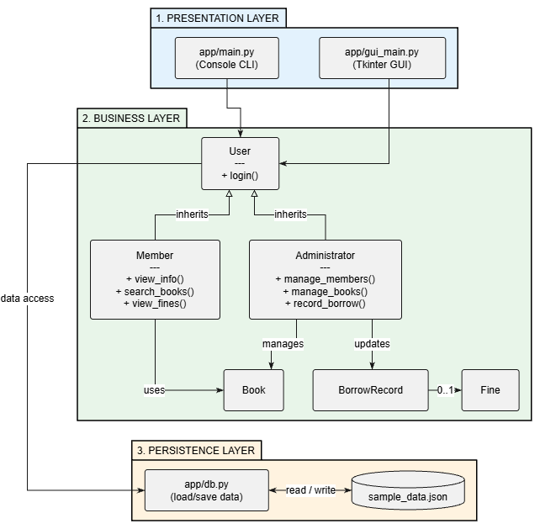

3. System Architecture (Layered Architecture -- Chapter 3)
The system is organized into 3 layers (Presentation / Business / Persistence); each layer only calls the layer directly below it. Full write-up with rationale: see docs/ARCHITECTURE.md.
PRESENTATION LAYER
app/main.py console app (keyboard-driven menu)
app/gui_main.py GUI entry point
app/gui/*.py Tkinter GUI (login_view, member_view, admin_view, dialogs, app)
-> calls methods on Member/Administrator objects only; no business rule lives here
|
v
BUSINESS LAYER (app/models.py)
User (base class: username, password, login())
|-- Member (extends User): view_personal_info(), search_books(),
| view_borrowed_books(), view_borrow_history(), view_fines()
`-- Administrator (extends User): add/update/delete/view Member & Book,
record_borrow(), record_return(), view_overdue_records(), pay_fine()
Book: check_availability(), update_quantity()
BorrowRecord: check_overdue(), record_return()
Fine: calculate_amount(), pay()
-> all business rules (login, search, borrow/return, overdue check,
fine calculation) live here; does not know console vs GUI
|
v
PERSISTENCE LAYER (app/db.py)
load_data() / save_data() <-> data/sample_data.json
-> only reads/writes data; knows nothing about business rules
Why Layered architecture
- Clear separation of concerns: the Presentation layer (console + GUI) does not know how data is stored; the Business layer does not care whether it is being displayed on console or Tkinter; the Persistence layer does not know which business rule triggered it.
- Both interfaces share one Business layer: app/main.py (console) and app/gui/*.py (Tkinter) both call methods directly on the same Member/Administrator objects from models.py -- no business logic is duplicated.
- Each layer can be replaced independently: db.py could be swapped for SQL Server/SQLite without touching models.py or any GUI/console file, since the layer above only works with Member/Book/BorrowRecord/Fine objects.
Mapping to the Class Diagram
- User is the base class; Member and Administrator inherit from User -- the inheritance relationship from the Stage 1/2 Class Diagram.
- Book, BorrowRecord, Fine are independent classes, each with its own attributes and behaviour (Book.check_availability()/update_quantity(); BorrowRecord.check_overdue()/record_return(); Fine.calculate_amount()/pay()).
- The 1 BorrowRecord -- 0..1 Fine relationship is preserved exactly as in the class diagram: a Fine is only created when a book is returned late, and never duplicated for the same record (Fine.find_for_record).
Each layer only calls the layer directly below it; both interfaces (console and GUI) share the same Business Layer classes. See README.md for the same description and the full package layout.

